ROSARY PRAYER GROUP for Death Row
Every Friday Evening at 8:00 PM
United We Have Power!

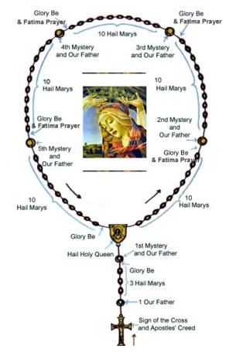

Over
Sorrowful Mysteries for Friday Evening Prayer
- The Agony in the Garden Spiritual Affect: God’s Will be done
Intention: For all those who work against the death penalty – May they have COURAGE and PERSERVERANCE.
2. The Scourging at the Pillar
Spiritual Affect: Repentance and Trust in God – Open their hearts to MERCY
Intention: for an end to the Death Penalty
3. The Crowning with Thorns
Spiritual Affect: Strength of Perseverance
Intention: For Prison Workers and Administrators – May they have PATIENCE.
4. The Carrying of the Cross
Spiritual Affect: Strength of Perseverance
Intention: For all inmates on Death Row.
5. The Crucifixion and Death of Jesus
Spiritual Affect: Forgiveness
Intention: For all inmates who were executed – May their Souls be at PEACE.
The Sign of the Cross: In the name of the Father of the Son and of the Holy Spirit. Amen
The Apostles' Creed: I believe in God the Father Almighty, Creator of heaven and earth; and in Jesus Christ, His only Son, our Lord; Who was conceived by the Holy Ghost, born of the Virgin Mary, suffered under Pontius Pilate, was crucified, died and was buried. He descended into hell. On the third day He arose again; He ascended into heaven,and sitteth at the right hand of God, the Father Almighty; from thence He shall come to judge the living and the dead. I believe in the Holy Ghost, the Holy Catholic Church, the communion of saints, the forgiveness of sins, the resurrection of the body, and life everlasting. Amen
The Our Father: Our Father, who art in heaven, hallowed be Thy name: Thy kingdom come: Thy will be done on earth as it is in heaven. Give us this day our daily bread: and forgive us our trespasses as we forgive those who trespass against us. And lead us not into temptation: but deliver us from evil. Amen.
The Hail Mary: Hail Mary, full of grace, the Lord is with thee: blessed art thou among women, and blessed is the fruit of thy womb, Jesus. Holy Mary, Mother of God, pray for us sinners, now and at the hour of our death. Amen
Glory be to the Father: Glory be to the Father, and to the Son and to the Holy Spirit.
As it was in the beginning, is now and ever shall be, world without end. Amen.
The Fatima Prayer: "O my Jesus, forgive us our sins, save us from the fires of hell, and lead all souls to Heaven, especially those in most need of Your Mercy".
The Hail, Holy Queen: Hail, holy Queen, Mother of Mercy! our life, our sweetness, and our hope! To thee do we cry, poor banished children of Eve; to thee do we send up our sighs, mourning and weeping in this valley, of tears. Turn, then, most gracious Advocate, thine eyes of mercy toward us; and after this our exile show unto us the blessed fruit of thy womb, Jesus; O clement, O loving, O sweet Virgin Mary.
Let Us Pray
"O God whose only begotten Son by His Life has purchased for us the rewards of eternal life, Grant that we beseech Thee while meditating upon these mysteries of the Most Holy Rosary of the Blessed Virgin Mary, we may both imitate what they contain and obtain what they promise, through the same Christ our Lord Amen." Pray for us, O holy Mother of God. That we may be made worthy of the promises of Christ.
Grant, we beseech thee,
O Lord God,
that we, your servants,
may enjoy perpetual health of mind and body;
and by the intercession of the Blessed Mary, ever Virgin,
may be delivered from present sorrow,
and obtain eternal joy. Through Christ Our Lord. Amen

